SIMATS ENGINEERING (SAVEETHA SCHOOL OF ENGINEERING)
Department of Computer Science and Engineering

ASSESSMENT TOOL 2 – Concept Mapping

Course Code: | CSA0305 | Course Title: |  | Data Structures
CO Assessed: | CO1 – Imitation (BL3, BL4) | Assessment: |  | Assessment Tool 2 – Concept Mapping
Weightage: | 35% of CIA | Total Marks: |  | 100
CO1 Statement: | Apply suitable data structures and ADTs for efficient problem solving by analyzing time and space complexity.
Student Name: | J. MEHER KOUSHIK |  | Reg. No.: | 192525211
Section / Batch: | AI&ML |  | Date: | 10/07/2026

Code of Conduct
I J. MEHER KOUSHIK (192525211) (Name / Reg No) certify that this submission is my original work and that I have adhered to the guidelines specified for this assessment. I understand that any violation of academic integrity rules will result in disciplinary action. Signature of the Student: J. MEHER KOUSHIK

Instructions
- This test contains 5 Concept mapping questions. Total: 100 Marks.
- When a student answer using a concept map, in evaluation the answer should be with following four requirements: Understanding of concepts, Connections between ideas, Logical structure, Clarity of representation.
- No negative marking. Unanswered questions carry zero marks.

Section / Topic | Focus | Q Nos | Marks
Linked data structure | Basic data structure | 1 | 20
Primitive and Non-Primitive Data Structure - Linear and Non-Linear Data Structure | Classifications of Linear data structure | 2 | 20
Search Data Structure | Linear Search and Binary Search | 3 | 20
Recursion, Performance analysis | Recursion | 4 | 20
Tree Data Structures | Classifications of Tree data structure | 5 | 20
 | GRAND TOTAL: | 100 Marks

Annexure A – Concept Mapping

- A student attendance system records daily presence data. Construct a concept map linking Array → Fixed Size → Sequential Access → Linked List → Dynamic Allocation → Flexibility. Explain how each structure works and justify which is more suitable for dynamic data
updates. (20 Marks)
- A weather monitoring system collects temperature, humidity, and wind data continuously. Construct a concept map linking Primitive Data Types → Non-Primitive Structures → Linear Structures → Non-Linear Structures → Applications. Include examples and explain how each
structure supports continuous data processing. (20 Marks)
- A digital archive stores millions of documents. Construct a concept map linking Searching → Linear Search → Binary Search → Sorted Data → Time Complexity → Performance. Analyze the impact of data organization on search efficiency and justify the best technique.
(20 Marks)
- A program processes nested expressions using recursion and may encounter deep nesting. Construct a concept map linking Recursion → Call Stack → Stack Overflow → Error Handling → Efficiency. Analyze potential issues and justify strategies to handle them. (20 Marks) 5. A company maintains hierarchical employee records with multiple levels of management. Construct a concept map connecting Tree → Nodes → Levels → Traversal (DFS/BFS) → Searching → Efficiency. Analyze how traversal techniques affect performance and justify the most suitable approach for retrieving employee data. (20 Marks)
Rubrics for Calculation

Criteria | Weightage | Level 4 – Exemplary |  | Level 3 –  Proficient | Level 2 –  Developing |  | Level 1 –  Beginning
Understanding  of  Problem Context | 20 | Clearly understands the problem and accurately identifies all  requirements |  | Good understanding with minor gaps | Basic understanding; some requirements unclear |  | Poor understanding or misinterpretation of the problem
Application of Concepts | 30 | Accurately applies appropriate concepts to solve complex problems |  | Applies relevant concepts correctly with minor errors | Applies basic concepts with limited accuracy |  | Fails to apply appropriate concepts
Problem-Solving Approach | 20 | Logical, well- structured, and efficient approach |  | Mostly logical approach with minor gaps | Basic approach with some inconsistencies |  | Illogical or unclear approach
Accuracy of Solution | 20 | Completely correct solution with proper justification |  | Mostly correct with minor errors | Partially correct solution |  | Incorrect or incomplete solution
Clarity | 10 | Clear, well- organized, and properly explained  solution |  | Understandable with minor clarity issues | Limited clarity and explanation |  | Poorly presented  and difficult to understand
Faculty In-charge |  |  | Course Coordinator |  |  | Program Director
Signature: _______________ |  |  | Signature: _______________ |  |  | Signature: _______________
Date: ___________________ |  |  | Date: ___________________ |  |  | Date: ___________________

1 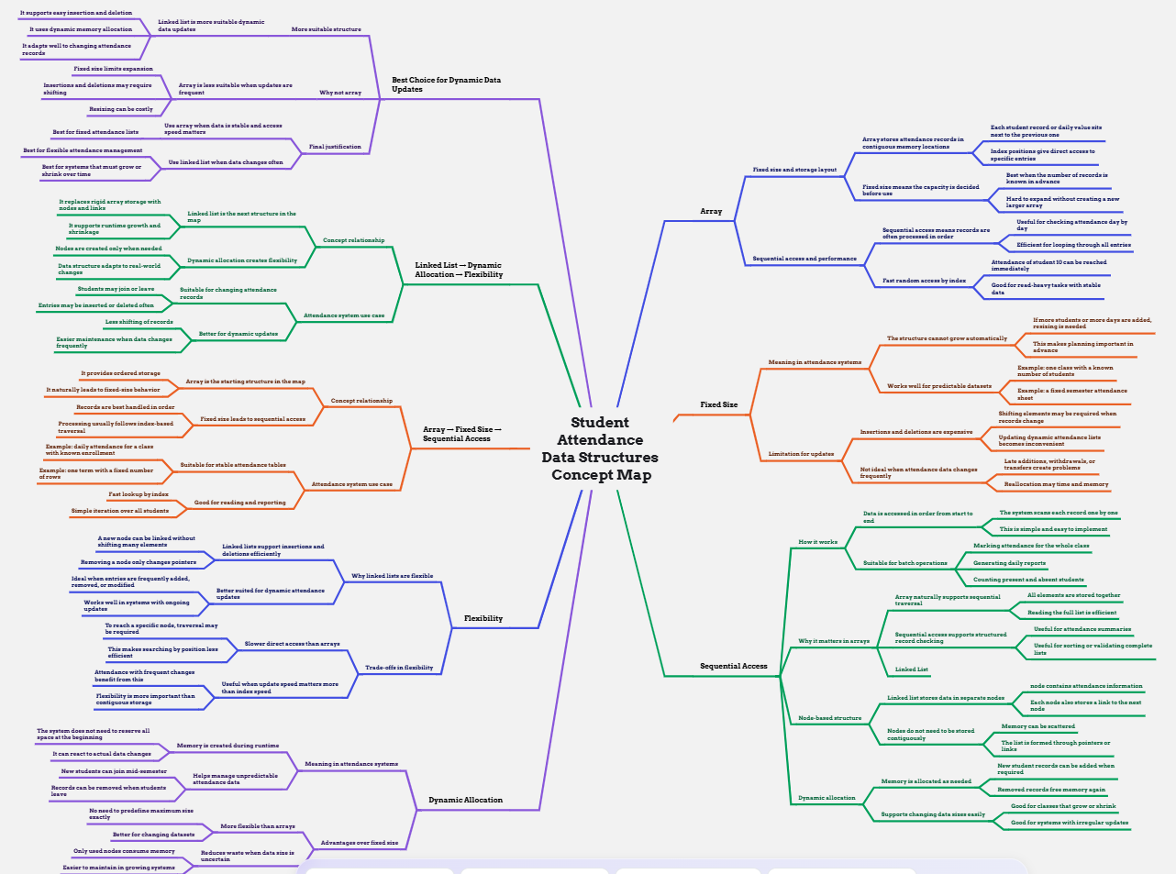

2:
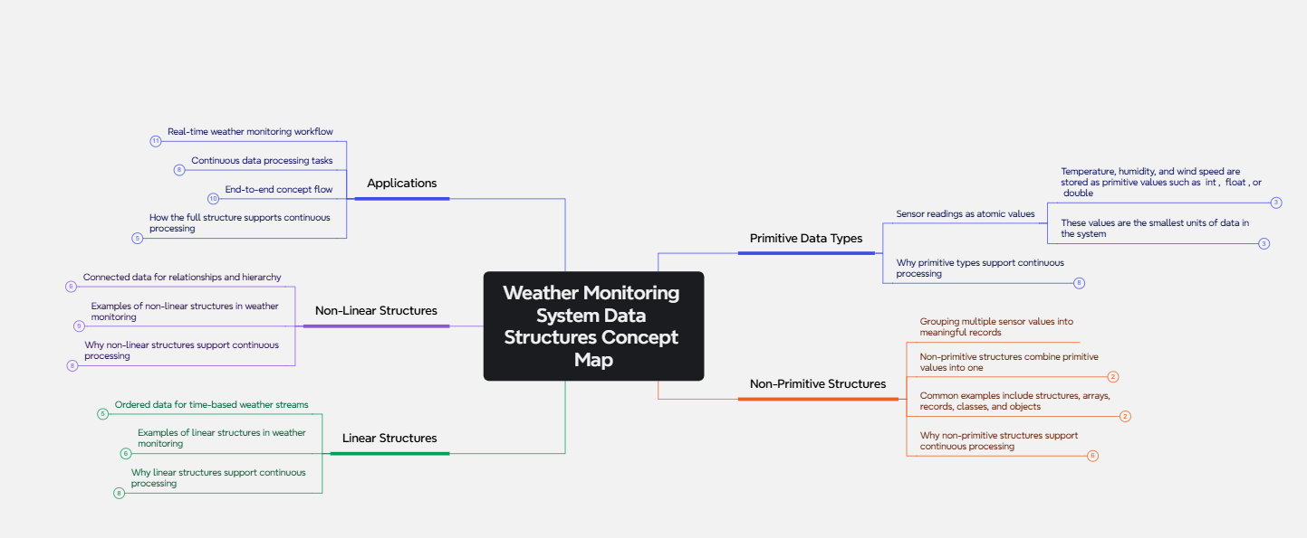

3:
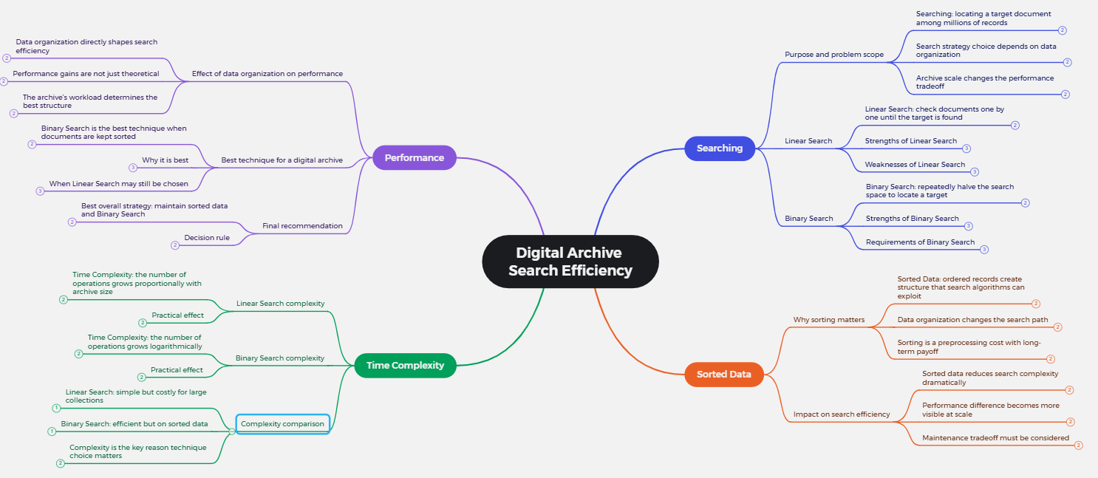

4:
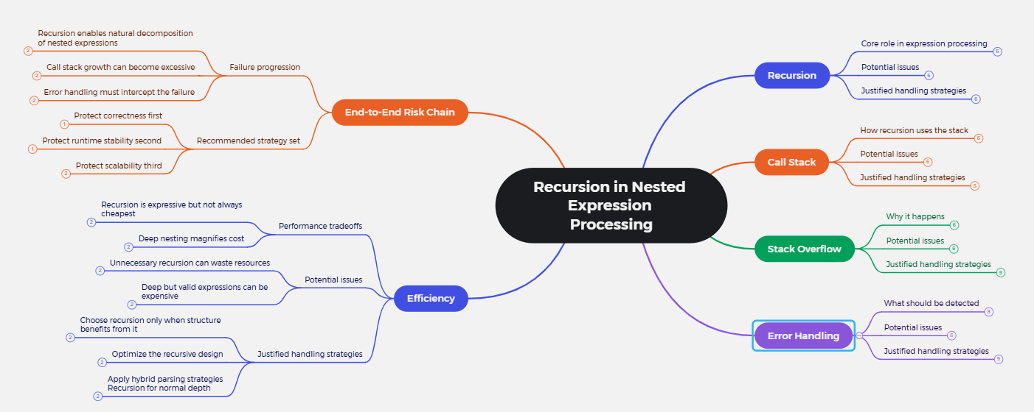

5.
